[GOOGLE EARTH ENGINE](EE01%20Earth%20Engine%20(EE).docx) [APPLICATION PROGRAMMING INTERFACE](EE05%20%20%20The%20EE%20API.docx) [CAPABILITIES](EE07%20%20%20%20%20%20API%20Capabilities.docx)

PROCESSING **MAP** [WIDGETS](EE08%20%20%20%20%20%20%20%20%20Widgets.docx)

A map is an EE widget object that represents the Mapping Panel of the EE web page, where geospatial data are displayed in a cartographic format. Maps can be processed by using operations of the types listed below, which vary according to the nature of that processing. Each operation name is linked to a separate page describing that operation.

**DOCUMENTING** MAPS MAPS Map.getBounds Map.getScale ee.data.getMapId

**PRESENTING** MAPSPS Map.setCenter Map.setStyle

[GOOGLE EARTH ENGINE](EE01%20Earth%20Engine%20(EE).docx) [APPLICATION PROGRAMMING INTERFACE](EE05%20%20%20The%20EE%20API.docx) [CAPABILITIES](EE07%20%20%20%20%20%20API%20Capabilities.docx)

**DOCUMENTING** MAP [WIDGETS](EE08%20%20%20%20%20%20%20%20%20Widgets.docx)

Map.getBounds reports the longitude and latitude coordinates of the four edges of the current map display.

fourNumbers = Map.getBounds ()

A list ( or GeoJSON object ) of four numbers respectively indicating the map’s current westerly, southerly, easterly, and northerly coordinates in decimal degrees,

var TheCOORDINATES = Map.getBounds( );

print( TheCOORDINATES );

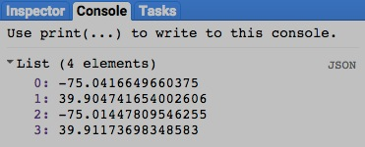

[GOOGLE EARTH ENGINE](EE01%20Earth%20Engine%20(EE).docx) [APPLICATION PROGRAMMING INTERFACE](EE05%20%20%20The%20EE%20API.docx) [CAPABILITIES](EE07%20%20%20%20%20%20API%20Capabilities.docx)

**DOCUMENTING** MAP [WIDGETS](EE08%20%20%20%20%20%20%20%20%20Widgets.docx)

Map.getScale reports the pixel size associated with the zoom level of the current map display.

newNumber = Map.getScale ()

The approximate number of meters represented by the horizontal or vertical width of each pixel in meters

var HowWIDE = Map.getScale( );

print( HowWIDE );

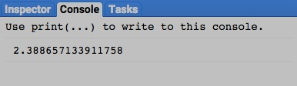

[GOOGLE EARTH ENGINE](EE01%20Earth%20Engine%20(EE).docx) [APPLICATION PROGRAMMING INTERFACE](EE05%20%20%20The%20EE%20API.docx) [CAPABILITIES](EE07%20%20%20%20%20%20API%20Capabilities.docx)

**DOCUMENTING** MAP [WIDGETS](EE08%20%20%20%20%20%20%20%20%20Widgets.docx)

ee.data.getMapId reports the Map ID and token associated with a specified asset.

newObject = ee.data.getMapId ( settings)

Instructions identifying data and data-display options in the same manner as **Map.addlayer** settings but with an additional setting given as **'id':** followed by the asset ID for a feature, feature collection, image, or image collection

A dictionary of strings associated with two keys: “mapid” and “token”

var TheMAPID = ee.data.getMapId( {'id':'srtm90_v4', min:0, max:700, palette:'001100,009900'} );

print( TheMAPID );

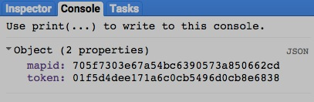

[GOOGLE EARTH ENGINE](EE01%20Earth%20Engine%20(EE).docx) [APPLICATION PROGRAMMING INTERFACE](EE05%20%20%20The%20EE%20API.docx) [CAPABILITIES](EE07%20%20%20%20%20%20API%20Capabilities.docx)

**PRESENTING** MAP [WIDGETS](EE08%20%20%20%20%20%20%20%20%20Widgets.docx)

Map.setCenter pans the map to center on a specified longitude and latitude at a specified level of detail.

Map.setCenter ( longitude*,* latitude*, zoomLevel* )

The specified longitude, given as a number referring to degrees

The specified latitude, given as a number referring to degrees

The specified level of detail, given as a number ranging from 1 (coarsest) to 20 (finest)

Map.setCenter( -77.00919270515442, 38.88981361419182, 15 );

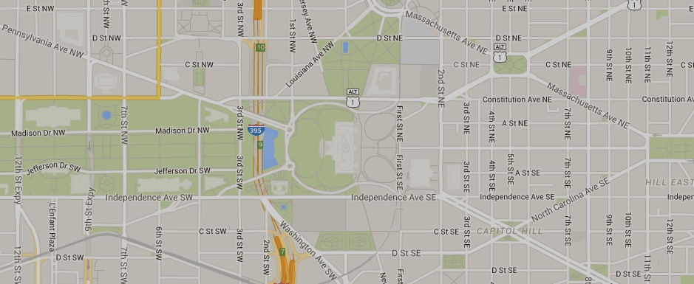

[GOOGLE EARTH ENGINE](EE01%20Earth%20Engine%20(EE).docx) [APPLICATION PROGRAMMING INTERFACE](EE05%20%20%20The%20EE%20API.docx) [CAPABILITIES](EE07%20%20%20%20%20%20API%20Capabilities.docx)

**PRESENTING** MAP [WIDGETS](EE08%20%20%20%20%20%20%20%20%20Widgets.docx)

Map.setStyle sets the current map’s background to user-specified settings. ( Additional capabilities are also advertised but seem not to work )

Map.setStyle ( *styleName*, *dictionaryOfStyles* )

The name of a user-created dictionary of styles as described [here](https://developers.google.com/maps/documentation/javascript/reference#MapTypeStyle)

One of the keys in *dictionaryOfStyles*

Map.setCenter( -77.00919270515442, 38.88981361419182, 15 );

Map.setStyle( 'NewTYPE',

{'NewTYPE':[ { featureType:'all', stylers:[{saturation:-100}] },

{ featureType:'road.arterial', stylers:[{saturation: 100}, {hue:'#ff0000'}] }, ] } );

